**ASSIGNMENT 2 – SALES DASHBOARD**

SALES BY CUSTOMER:

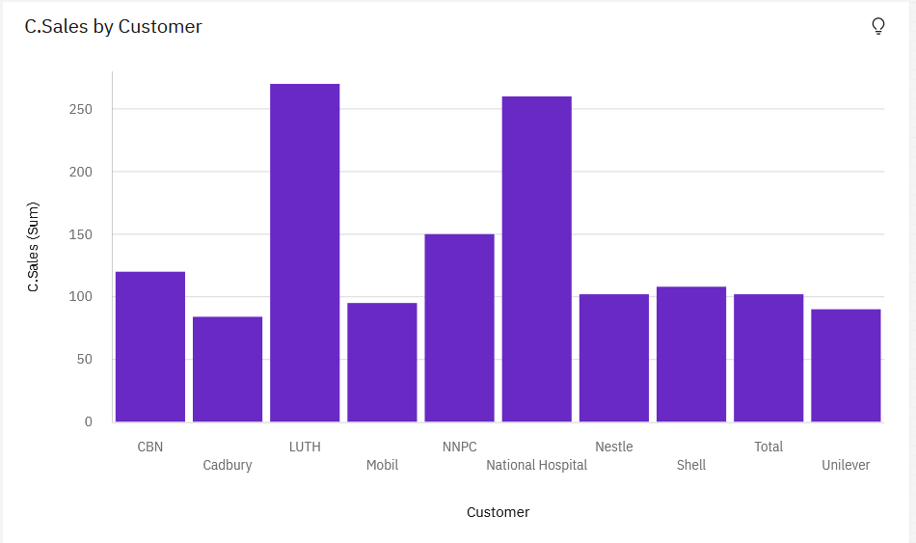

SALES BY LOCATION:

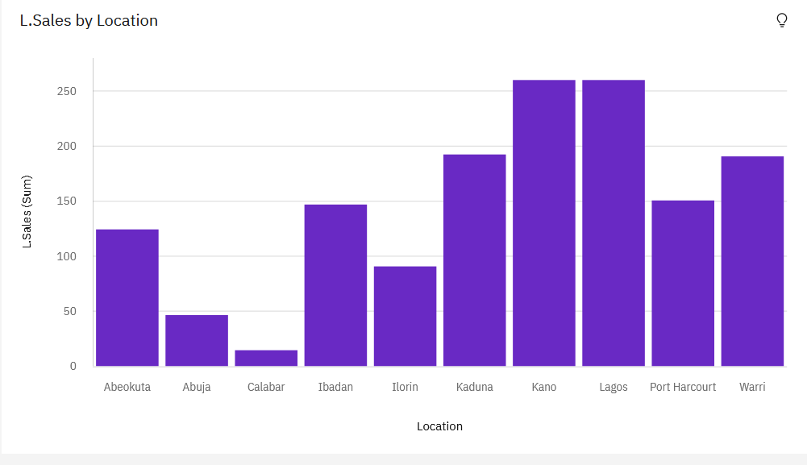

SALES BY REPRESENTATIVE:

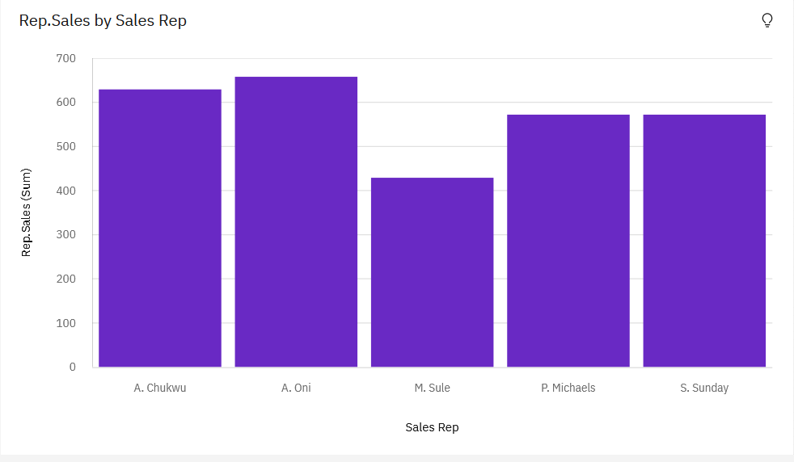

RECEIVED INVENTORY FROM SUPPLIER:

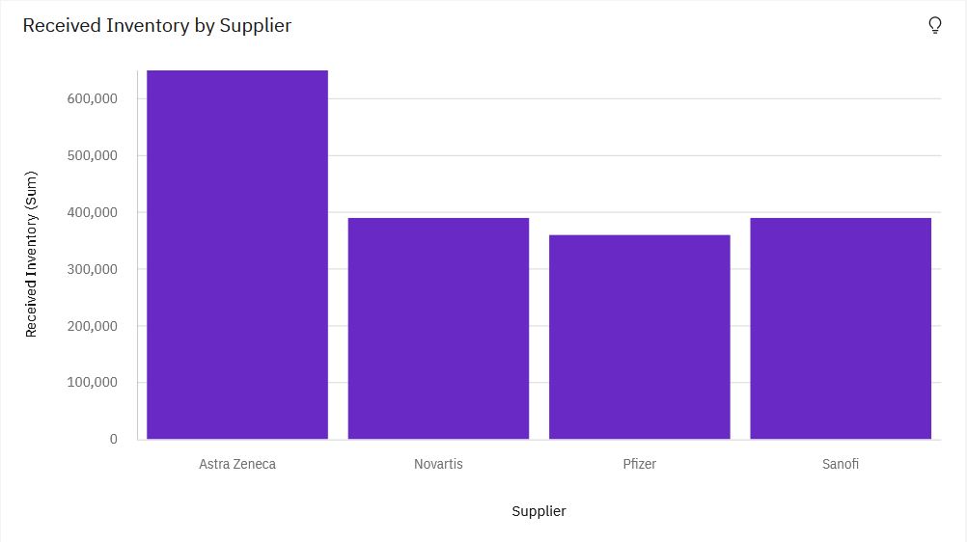

INVENTORY STOCK FOR WAREHOUSE LOCATIONS:

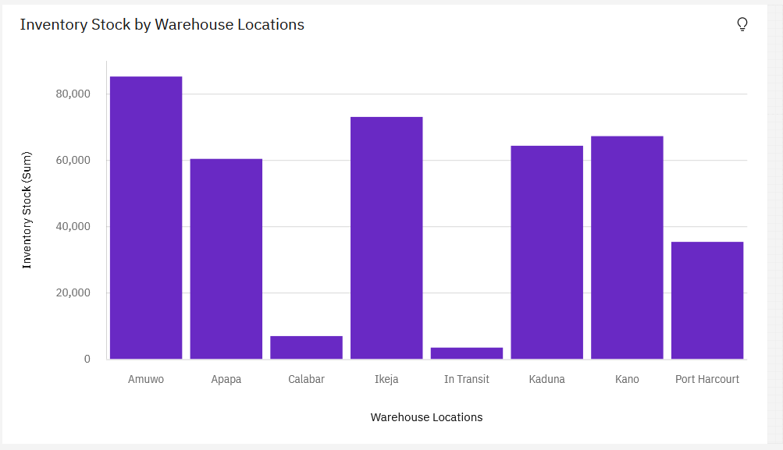

SALES TREND:

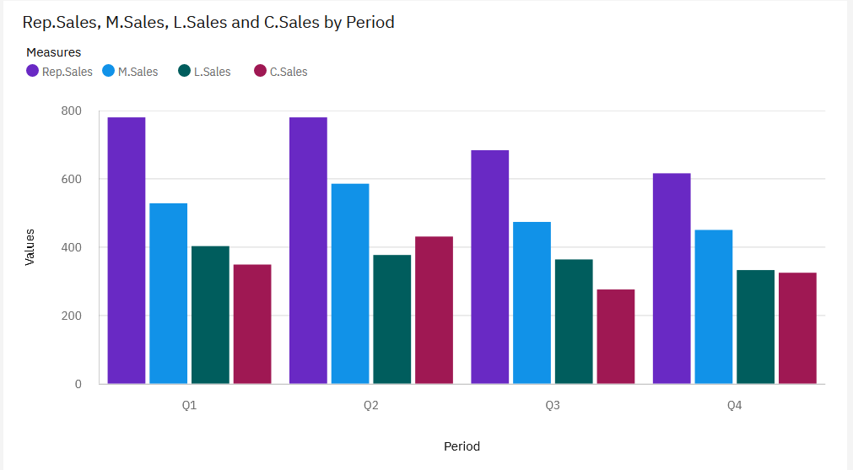

MONTHLY SALES:

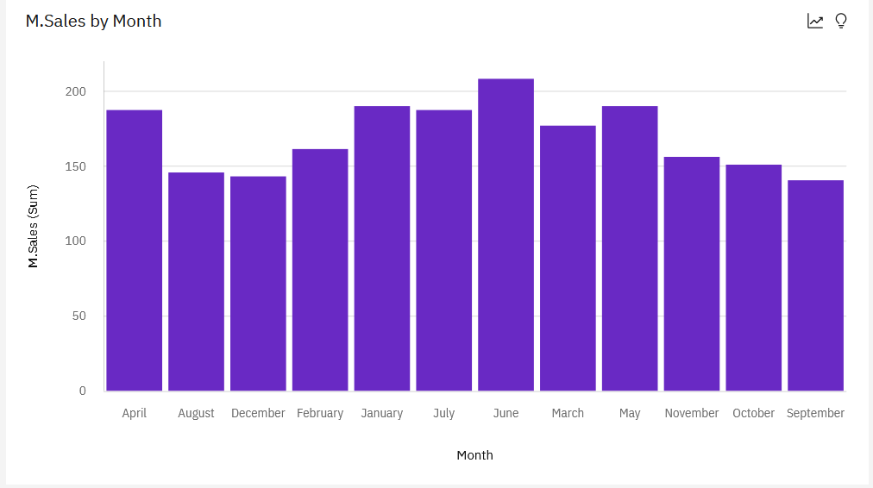

ACTUAL AND RECEIVED INVENTORY BY MONTH:

